**Task design and reflection**

1. Students’ backgrounds and abilities:

- The learning diversity in learning Mathematics is big – 1/3 of them with high-ability, 1/3 of them with fair-ability, 1/3 of them with low ability.

- High-ability students are willing to take care of slow learners.

- Students are a little bit afraid of learning in English and using English to present. (All students do not have high-ability in English)

- Students are willing to learn through different methods, especially in group tasks.

2. Teaching Strategy: (Show how your task design meets the judging criteria)

As shopping at the supermarket is a part of our daily lives, students were arranged into small groups and asked to pretend to be buying snacks at the supermarket. They had to activate their prior knowledge from ‘round off’ to ‘round up’ and ‘round down’. Apart from discussing effective purchasing strategies, the language of Mathematics was introduced to communicate ideas, for example, ‘Before rounding, the price is [*$______*].  After rounding [*off/ up/ down*] to the nearest [*$dollar/10/100*], the price is [*$______*].’ By highlighting the applications of mathematics in the real-life, students were encouraged to appreciate mathematics and its significance in various areas.

3. Content of Task Design:

Basic Information

|  |  |
| --- | --- |
| Subject: S1 Mathematics | Time: 45 mins (1 period) |
| Medium of Instruction: English |
| Topic | Approximation and Estimation |
| Teaching Objective | Students can apply suitable estimation methods/ approaches according to different situations |
| Anticipated Learning Difficulties | Students have to decide the best solution themselves with limited resources |
| Prior knowledge | The ideas of “Round off, Round up, and Round down:  The ideas of “correct to……” |
| Use of teaching strategies and activities | * Collaborative Learning: * Divide into small group   One high-ability student with two members (10 groups)   * Catering for learner diversity * Increase the opportunities of discussion * Group discussion * Mathematics Talk * Idea generation * Explanation * Questioning * Students presentation |
| Preparation before the lesson: | * Revision on estimation calculation      * Revision on an oral phrase * “Before rounding, the price is [*$____*]. After rounding *[off/ up/ down*] to the nearest [*dollar/ 10/ 100*], the price is [*$____*]” |

Teaching Procedures

|  |  |  |  |  |
| --- | --- | --- | --- | --- |
|  | Teaching activities | Teaching tools | Objectives | Time  (mins) |
| Lead in | Teacher-to-students   * Introduce the task design * Set up the final target for “The Best Award” * Buy snacks as many as they can and/or;  * Use money as much as they can      * Complete the first part of worksheet * Record the price of each snacks | * PowerPoints * Worksheet | * Students can have a clear picture on what they are going to experience | 7 |
| Group discussion | Students-to-students   * Discuss the best strategy to win * To buy or not to buy * If buy, then use which approaches * Do practice on the oral phrase | * Worksheet * Calculator | * Occur Mathematics dialogue * Generate ideas | 8 |

|  |  |  |  |  |
| --- | --- | --- | --- | --- |
| Activities time  (Display learning products) | Students-to-students and Students-to-teacher  *Please refer to the attachment for the brief game rules | * Worksheet | * From group discussion to whole class discussion | 25 |
| Summary and reflections | Teacher-to-students   * Debrief * Teacher articulates some special finding during group discussion   e.g. “A cake is costed $3.2, but if we round down it to the nearest dollar, then we can get it for free!”  e.g. “A pocky is costed $4.7, no matter we round up or round off to the nearest dollar, the result would be the same, just $5.” | * Worksheet |  | 5 |

4. Students’ feedback:

The students reflected that

* the learning experience is happy and engaging.
* they can have a deep understanding on the real application of this topic.

5. Teacher reflection:

* Learning objectives are clear and student-centred.
* Students’ preparation before class is suitable for their abilities and conducive to classroom learning.
* The lesson design enhances students’ interest, motivation and confidence in learning.
* All students can participate in the class activities.
* Students help each other and construct knowledge together during collaborative learning.
* The classroom makes good use of physical environment to facilitate teaching and learning.
* The learning activities help students to reflect on and evaluate their learning progress and achievements.
* Students provided with immediate feedback and opportunities to demonstrate what they have learned.

Attachment:

Some PowerPoints slides:

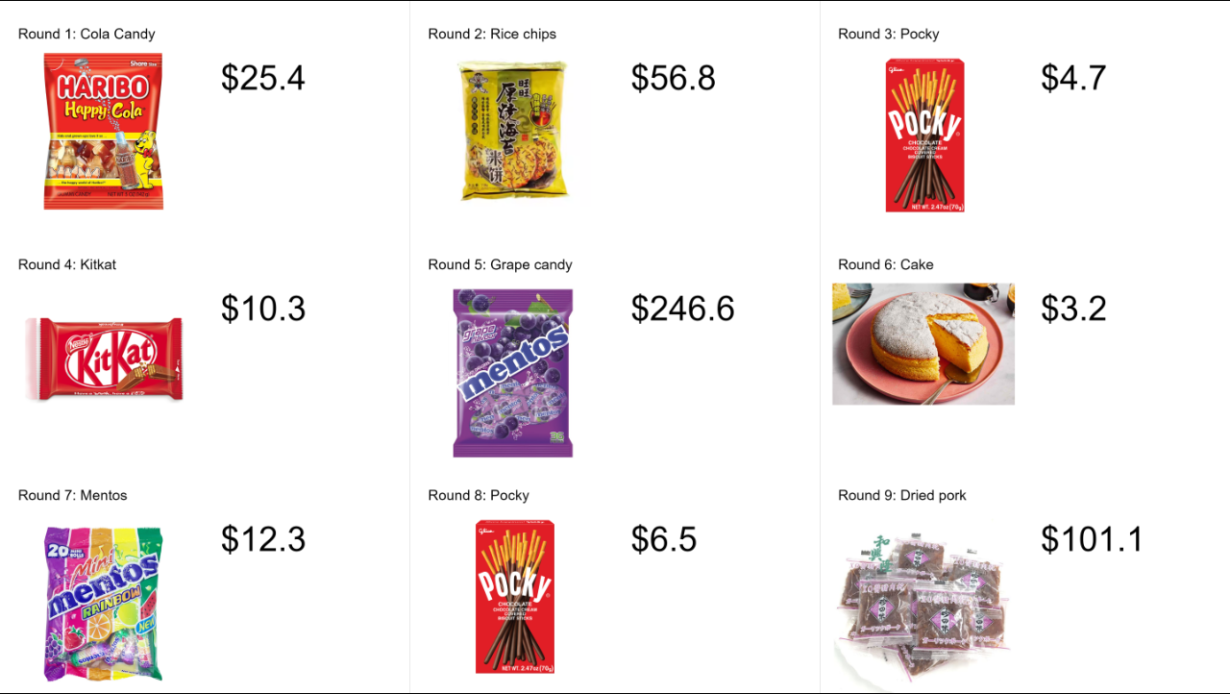 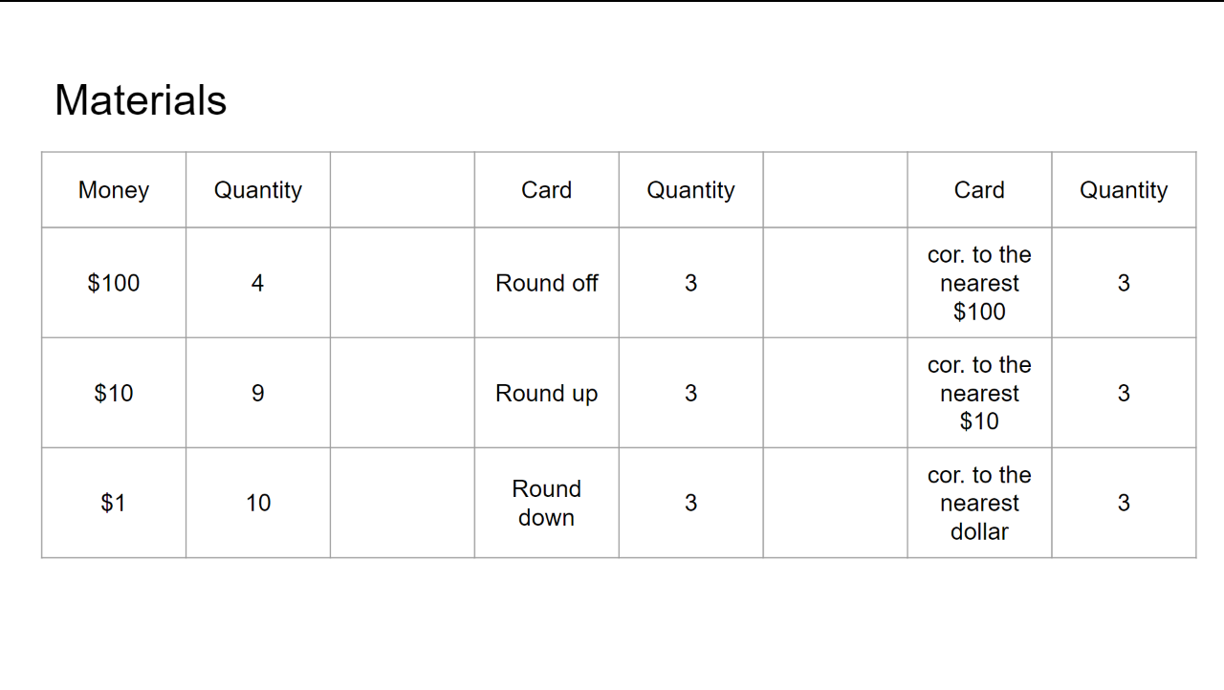 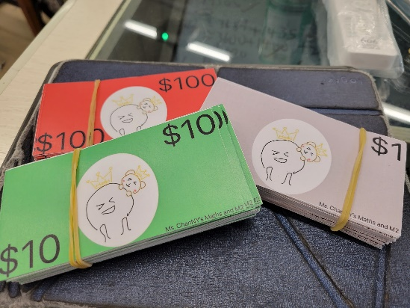

Show how much is each snack Show what materials that each group can get Some props

Game rules:

1. There are total 9 rounds.

2. Each group can choose to buy or not to buy in each round.

3. Each group can only purchase maximum one snack in each round.

4. If they choose to purchase, they have to use “Round off/ up/ down” card and “Correct to the nearest dollar/ $10/ $100” card at the same time.

5. Each group should pay accordingly – exact amount, not higher and not lower.